Morris Kim

1. a) Species inherits from Genus. Species is the child class and Genus is the super class.

b) A specimen cannot exist without a species (composition)

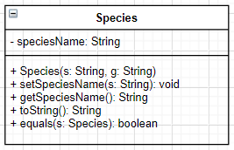c)

d) – Through inheritance, programmers can write code in a more readable and efficient manner. When the child class inherits from the parent class, the programmers’ don’t need to rewrite the same functions and attributes.  
- The composition relationship between specimen and species allows for a stronger encapsulation between the 2 classes.

e) i) This is because the toString() method in the species class overrides the method in the genus class. Calling the method will run the code written in the species class instead of the one in the parent class.

ii) method overriding/dynamic polymorphism

2.a) encapsulation refers to one of the fundamentals of OOP where you hide values to prevent direct access to them.

b) – It’s more secure against unauthorized parties  
- It’s more secure for the programmer, as it is less likely to be modified by code in a different part of the program

c) getCage()

d) cageNumber

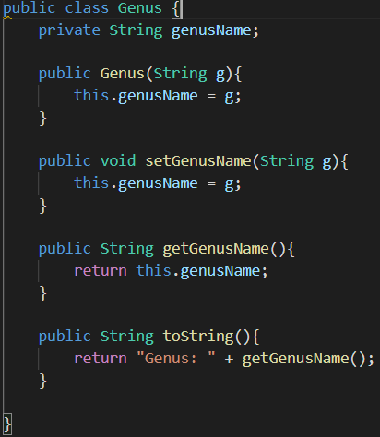e)

f) – Advantage: can reuse the get and set methods for the species name

- Disadvantage: the equals function would be unused

3. a) – Add a new private instance variable in the Specimen class that lets the user specify the specimen’s individual marking, along with the get/set methods to retrieve/change its value.  
- The Specimen class’ toString() method can also be changed to accommodate the new variable as a part of its returned string.

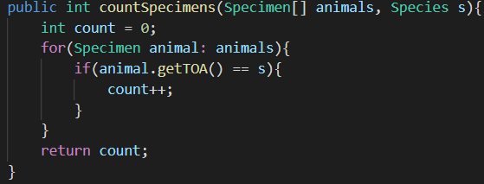b)

c)

function listSpecies (animals: Specimen[])  
 string speciesList[]  
 int count = 0  
 for animal in animals  
 if animal.getTOA() is not in speciesList  
 speciesList[count] = animal.getTOA()  
 count = count + 1  
 for species in speciesList  
 output species

4. a) – Helps store data (e.g. Linked list, set, graph)  
 - has a functional system with methods (e.g. pop, push with stacks)

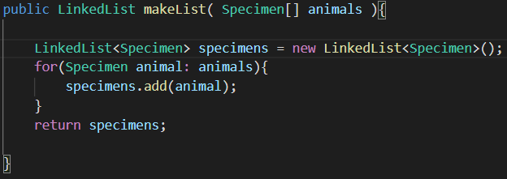b)

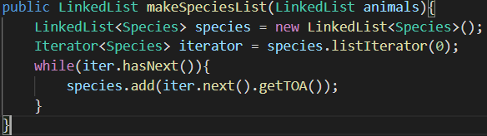

c)

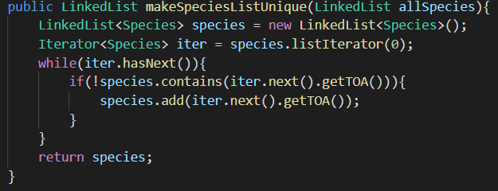

d)